- Define Software. What are the characteristics of software?

Software is a set of instructions, data or programs used to operate computers and execute specific tasks.

Software is considered to be collection of executable programming code, associated libraries and documentations. Software, when made for a specific requirement is called software product.
IEEE defines software engineering as:
The Institute of Electrical and Electronic Engineers (IEEE) defines software as a ‘collection of computer programs, procedures, rules and associated documentation and data.’

Software Characteristics
• Functionality: Refers to the degree of performance of the software against its intended purpose.
• Reliability: Refers to the ability of the software to provide desired functionality under the given conditions.
• Usability: Refers to the extent to which the software can be used with ease.
• Efficiency: Refers to the ability of the software to use system resources in the most effective and efficient manner.
• Maintainability: Refers to the ease with which the modifications can be made in a software system to extend its functionality, improve its performance, or correct errors.
• Portability: Refers to the ease with which software developers can transfer software from one platform to another, without (or with minimum) changes. In simple terms, it refers to the ability of software to function properly on different hardware and software platforms without making any changes in it.
In addition to the above mentioned characteristics, robustness and integrity are also important.
Robustness refers to the degree to which the software can keep on functioning in spite of being provided with invalid data while integrity refers to the degree to which unauthorized access to the software or data can be prevented.

2.Define Software Engineering. What are the four layers of SE ?
According to IEEE, software engineering is defined as ‘the application of a systematic, disciplined, quantifiable approach to the development, operation, and maintenance of software; that is, the application of engineering to software.’
In a nutshell, software engineering can be defined as a systematic approach to develop software within specified time and budget.

A Layered Technology
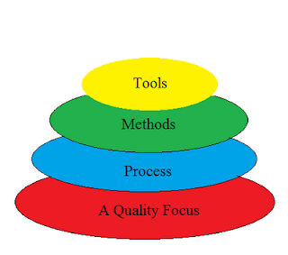
Divided into 4 layers:-
1. A quality Process :-
- Any engineering approach must rest on an quality.
- The "Bed Rock" that supports software Engineering is Quality Focus.
2. Process :-
- Foundation for SE is the Process Layer
- SE process is the GLUE that holds all the technology layers together and enables the timely development of computer software.
- It forms the base for management control of software project.
3. Methods :-
- SE methods provide the "Technical Questions" for building Software.
- Methods contain a broad array of tasks that include communication requirement analysis, design modeling, program construction testing and support.
4. Tools :-
- SE tools provide automated or semi-automated support for the "Process" and the "Methods".
- Tools are integrated so that information created by one tool can be used by another.

3.Write an explanatory note on the changing nature of software.

Changing Nature of Software:
Nowadays, seven broad categories of computer software present continuing challenges for software engineers .which is given below:
- System Software:
System software is a collection of programs which are written to service other programs. Some system software processes complex but determinate, information structures. Other system application process largely indeterminate data. Sometimes when, the system software area is characterized by the heavy interaction with computer hardware that requires scheduling, resource sharing, and sophisticated process management.
- Application Software:
Application software is defined as programs that solve a specific business need. Application in this area process business or technical data in a way that facilitates business operation or management technical decision making. In addition to convention data processing application, application software is used to control business function in real time.

- Engineering and Scientific Software:
This software is used to facilitate the engineering function and task. however modern application within the engineering and scientific area are moving away from the conventional numerical algorithms. Computer-aided design, system simulation, and other interactive applications have begun to take a real-time and even system software characteristic.
- Embedded Software:
Embedded software resides within the system or product and is used to implement and control feature and function for the end-user and for the system itself. Embedded software can perform the limited and esoteric function or provided significant function and control capability.
- Product-line Software:
Designed to provide a specific capability for use by many different customers, product line software can focus on the limited and esoteric marketplace or address the mass consumer market.
- Web Application:
It is a client-server computer program which the client runs on the web browser. In their simplest form, Web apps can be little more than a set of linked hypertext files that present information using text and limited graphics. However, as e-commerce and B2B application grow in importance. Web apps are evolving into a sophisticate computing environment that not only provides a standalone feature, computing function, and content to the end user.
- Artificial Intelligence Software:
Artificial intelligence software makes use of a nonnumerical algorithm to solve a complex problem that is not amenable to computation or straightforward analysis. Application within this area includes robotics, expert system, pattern recognition, artificial neural network, theorem proving and game playing

4.What are the various software myths? Elaborate.
Here, we have the list of some common myths of software in software engineering according to the category:
1. Management myths: The managers are often grasps at a belief in a software myth, same as a drowning person who grasps at a straw.
- Members acquires all the information: Generally, there is a myth that the members of the organization acquire all the information containing procedures, principles and standards. In reality, the developers don’t have information about all the established standards because they are often outdated, incomplete and unadaptable. Plus, there is a rare chance that the developer will follow all the standards.
- Adding more people can reduce the time gap: Another myth in the people is that more the number of programmers, lesser will be the time gap. If a project is behind the schedule, adding more manpower will further delay it because new workers will take more time to learn about the ongoing project.
- The management can relax themselves by outsourcing its project: If an organization outsource its software to a third party, it does not relieve the management of its duties. When the organization outsources the software project, they suffer invariably.
2. Customers Myths: The customers are encouraged by some marketing people in underestimating the difficulty of developing software.
- Software is malleable as a result of which changes are easy to accommodate: There is an enormous amount of labor required to have a change in the software after the release. It is not so easy to accommodate these changes.
- To start coding, a general statement of need is enough: The developers can’t read the customer’s mind and requires detailed descriptions of the requirements, in order to start coding.
3. Developer Myths: The software development art is becoming an engineering discipline, but there are lots of myths.
- Once the code is delivered, the software can be called complete: In reality, more than 60% of the efforts are expended after the delivery of the software to the user.
- The software’s success depends on the product’s produced quality: The project does not become successful on the quality of the programs because both the software configuration and documentation also play an important role in its success.
- The unnecessary documentation is required in software engineering, which further slows down the growth rate of a project: This myth is a no brainer because in reality, the proper documentation enhances the project’s quality and results in reduction of the rework. Also, this field is just about creating quality at all the level of the project.
- The assessment of the software quality can be addressed after the execution of the program: During any phase of the development process, the software’s quality can be measured just by applying the mechanism of quality assurance.
- The product, which is delivered after the project’s completion can be called working program: The deliverables of a successful project don’t only consist working program, but also the documentation which can guide the users about how to use the software.

5.Describe the Software Process Framework in detail.

Framework is a Standard way to build and deploy applications. Software Process Framework is a foundation of complete software engineering process. Software process framework includes all set of umbrella activities. It also includes number of framework activities that are applicable to all software projects.
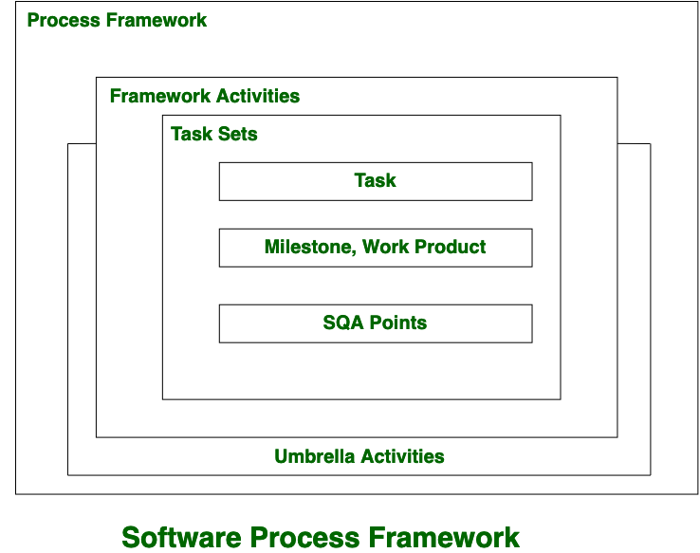
A generic process framework encompasses five activities which are given below one by one:
- Communication:
In this activity, heavy communication with customers and other stakeholders, requirement gathering is done.
- Planning:
In this activity, we discuss the technical related tasks, work schedule, risks, required resources etc.
- Modeling:
Modeling is about building representations of things in the ‘real world’. In modeling activity, a product’s model is created in order to better understanding and requirements.
- Construction:
In software engineering, construction is the application of set of procedures that are needed to assemble the product. In this activity, we generate the code and test the product in order to make better product.
- Deployment:
In this activity, a complete or non-complete products or software are represented to the customers to evaluate and give feedback. on the basis of their feedback we modify the products for supply better product.
Typical umbrella activities are:
1. Software project tracking and control
- In this activity, the developing team accesses project plan and compares it with the predefined schedule.
- If these project plans do not match with the predefined schedule, then the required actions are taken to maintain the schedule.
2. Risk management
- Risk is an event that may or may not occur.
- If the event occurs, then it causes some unwanted outcome. Hence, proper risk management is required.
3. Software Quality Assurance (SQA)
- SQA is the planned and systematic pattern of activities which are required to give a guarantee of software quality.
For example, during the software development meetings are conducted at every stage of development to find out the defects and suggest improvements to produce good quality software.
4. Formal Technical Reviews (FTR)
- FTR is a meeting conducted by the technical staff.
- The motive of the meeting is to detect quality problems and suggest improvements.
- The technical person focuses on the quality of the software from the customer point of view.
5. Measurement
- Measurement consists of the effort required to measure the software.
- The software cannot be measured directly. It is measured by direct and indirect measures.
- Direct measures like cost, lines of code, size of software etc.
- Indirect measures such as quality of software which is measured by some other factor. Hence, it is an indirect measure of software.
6. Software Configuration Management (SCM)
- It manages the effect of change throughout the software process.
7. Reusability management
- It defines the criteria for reuse the product.
- The quality of software is good when the components of the software are developed for certain application and are useful for developing other applications.
8. Work product preparation and production
- It consists of the activities that are needed to create the documents, forms, lists, logs and user manuals for developing a software.

6.What is the significance of a process model? Explain the waterfall/incremental/RAD model with related merits and demerits.
Software Processes is a coherent set of activities for specifying, designing, implementing and testing software systems. A software process model is an abstract representation of a process that presents a description of a process from some particular perspective. There are many different software processes but all involve:
- Specification – defining what the system should do;
- Design and implementation – defining the organization of the system and implementing the system;
- Validation – checking that it does what the customer wants;
- Evolution – changing the system in response to changing customer needs.
The most used, popular and important SDLC models are given below:
- Waterfall model
- V model
- Incremental model
- RAD model
- Agile model
- Iterative model
- Spiral model
- Prototype model

Waterfall Model
The waterfall model is a breakdown of project activities into linear sequential phases, where each phase depends on the deliverables of the previous one and corresponds to a specialisation of tasks. The approach is typical for certain areas of engineering design.
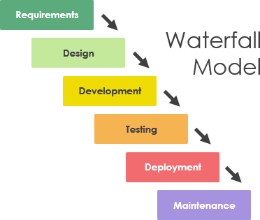

1. Communication
In the communication phase, the major task performed is requirement gathering which helps in finding out the exact need of the customer. Once all the needs of the customer are gathered the next step is planning.

2. Planning
In planning major activities like planning for schedule, keeping tracks on the processes and the estimation related to the project are done. Planning is even used to find the types of risks involved throughout the projects. Planning describes how technical tasks are going to take place and what resources are needed and how to use them.

3. Modeling
This is one of the important phases of the architecture of the system is designed in this phase. An analysis is carried out and depending on the analysis a software model is designed. Different models for developing software are created depending on the requirements gathered in the first phase and the planning done in the second phase.

4. Construction
The actual coding of the software is done in this phase. This coding is done based on the model designed in the modeling phase. So, in this phase software is developed and tested.

5. Deployment
In this last phase, the product is rolled out or delivered & installed at the customer’s end and support is given if required. Feedback is taken from the customer to ensure the quality of the product.

Advantages of the Waterfall Model
- This model is very simple and is easy to understand.
- Phases in this model are processed one at a time.
- Each stage in the model is clearly defined.
- This model has very clear and well undestood milestones.
- Process, actions and results are very well documented.
- Reinforces good habits: define-before- design,
design-before-code.
- This model works well for smaller projects and projects where requirements are well
understood.

Disadvantages of Waterfall Model
- You cannot go back a step; if the design phase has gone wrong, things can get overly complicated in the implementation phase.
- Often, the client is not clear of what he exactly wants from the software. Any changes that he mentions in between, may cause a lot of confusion.
- Minor changes or errors that arise in the completed software may cause a lot of problems.
- Until the final stage of the development cycle is complete, a working model of the software does not lie in the hands of the client. Thus, he is hardly able to inform the developers, if what has been designed is exactly what he had asked for.

Incremental model
The incremental build model is a method of software development where the model is designed, implemented and tested incrementally (a little more is added each time) until the product is finished. It involves both development and maintenance. The product is defined as finished when it satisfies all of its requirements. Each iteration passes through the requirements, design, coding and testing phases. And each subsequent release of the system adds function to the previous release until all designed functionally has been implemented. This model combines the elements of the waterfall model with the iterative philosophy of prototyping.
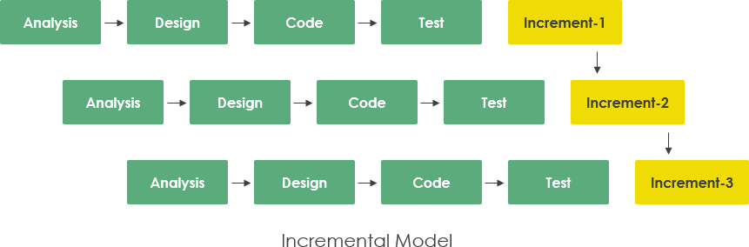dvantages of Incremental model:
- Generates working software quickly and early during the software life cycle.
- This model is more flexible – less costly to change scope and requirements.
- It is easier to test and debug during a smaller iteration.
- In this model customer can respond to each built.
- Lowers initial delivery cost.
- Easier to manage risk because risky pieces are identified and handled during it’d iteration.
Disadvantages of Incremental model:
- Needs good planning and design.
- Needs a clear and complete definition of the whole system before it can be broken down and built incrementally.
- Total cost is higher than waterfall.

What is RAD Model?
RAD Model or Rapid Application Development model is a software development process based on prototyping without any specific planning. In RAD model, there is less attention paid to the planning and more priority is given to the development tasks. It targets at developing software in a short span of time.
SDLC RAD modeling has following phases
- Business Modeling
- Data Modeling
- Process Modeling
- Application Generation
- Testing and Turnover
- 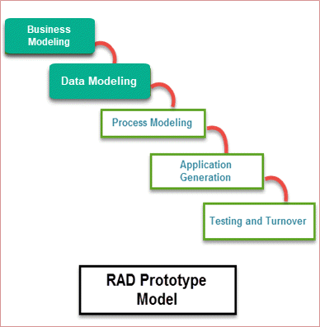
- 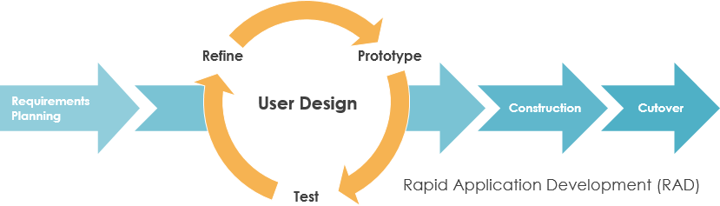
Advantages of RAD Model | Disadvantages of RAD Model
- Flexible and adaptable to changes | - It can't be used for smaller projects
- It is useful when you have to reduce the overall project risk | - Not all application is compatible with RAD
- It is adaptable and flexible to changes | - When technical risk is high, it is not suitable
- It is easier to transfer deliverables as scripts, high-level abstractions and intermediate codes are used | - If developers are not committed to delivering software on time, RAD projects can fail
- Due to code generators and code reuse, there is a reduction of manual coding | - Reduced features due to time boxing, where features are pushed to a later version to finish a release in short period
- Due to prototyping in nature, there is a possibility of lesser defects | - Reduced scalability occurs because a RAD developed application begins as a prototype and evolves into a finished application
- Each phase in RAD delivers highest priority functionality to client | - Progress and problems accustomed are hard to track as such there is no documentation to demonstrate what has been done
- With less people, productivity can be increased in short time | - Requires highly skilled designers or developers

7Explain the evolutionary process models prototyping/spiral/concurrent development model with relevant diagrams.

Advantages and Disadvantages of Prototype model
- Last Updated : 10 May, 2020
Prototyping Model is used when the customers do not know the exact project requirements beforehand. In this model, a prototype of the end product is first developed, tested and refined as per customer feedback repeatedly till a final acceptable prototype is achieved which forms the basis for developing the final product.
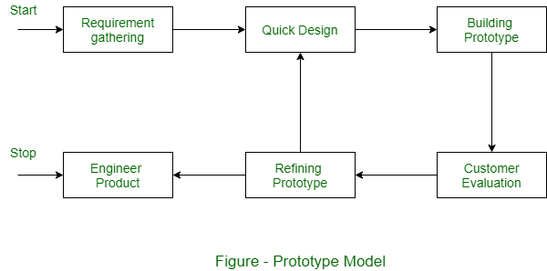
System is partially implemented before or during the analysis phase thereby giving the customers an opportunity to see the product early in the life cycle.
Advantages of using Prototype Model :
- This model is flexible in design.
- It is easy to detect errors.
- We can find missing functionality easily.
- There is scope of refinement, it means new requirements can be easily accommodated.
- It can be reused by the developer for more complicated projects in the future.
- It ensures a greater level of customer satisfaction and comfort.
- It is ideal for online system.
- It helps developers and users both understand the system better.
- Integration requirements are very well understood and deployment channels are decided at a very early stage.
- It can actively involve users in the development phase.
Disadvantages of using Prototype Model :
- This model is costly.
- It has poor documentation because of continuously changing customer requirements.
- There may be too much variation in requirements.
- Customers sometimes demand the actual product to be delivered soon after seeing an early prototype.
- There may be sub-optimal solutions because of developers in a hurry to build prototypes.
- Customers may not be satisfied or interested in the product after seeing the initial prototype.
- There is certainty in determining the number of iterations.
- There may be incomplete or inadequate problem analysis.
- There may increase the complexity of the system.

Advantages and Disadvantages of using Spiral Model
- Last Updated : 10 May, 2020
Spiral model is also known as Meta Model because it subsumes all the other SDLC models. In its diagrammatic representation, it looks like a spiral with many loops, that’s the reason it’s called as Spiral. Each loop of the spiral is called a Phase of the software development process. This model has capability to handle risks.
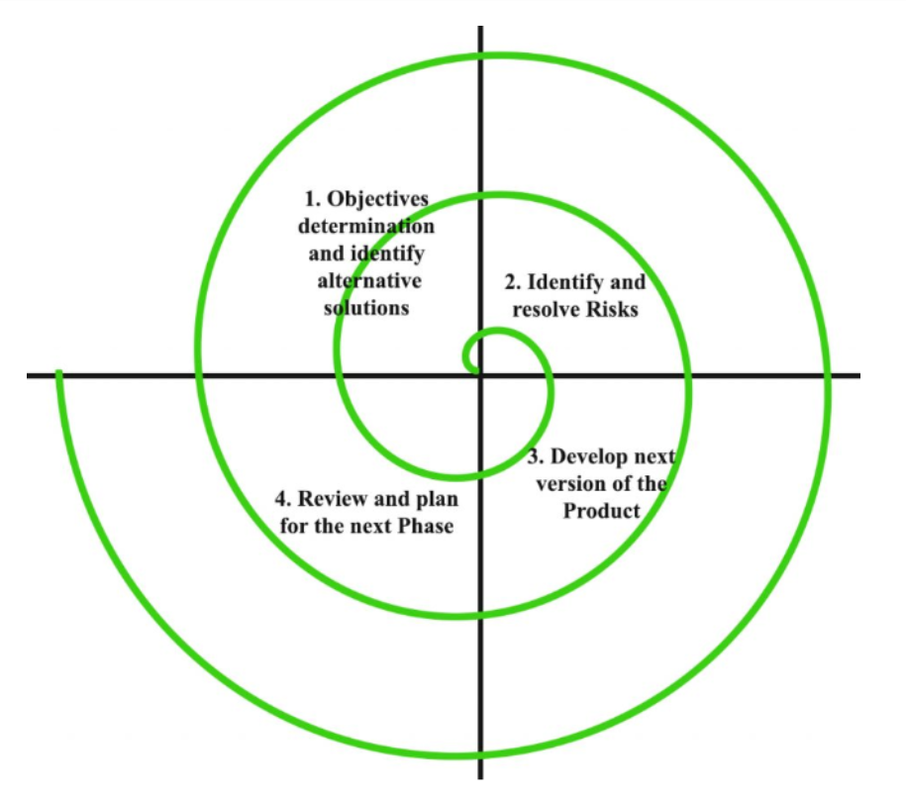
These are following advantages and disadvantages of using Spiral Model
Advantages of Spiral Model:
- Software is produced early in the software life cycle.
- Risk handling is one of important advantages of the Spiral model, it is best development model to follow due to the risk analysis and risk handling at every phase.
- Flexibility in requirements. In this model, we can easily change requirements at later phases and can be incorporated accurately. Also, additional Functionality can be added at a later date.
- It is good for large and complex projects.
- It is good for customer satisfaction. We can involve customers in the development of products at early phase of the software development. Also, software is produced early in the software life cycle.
- Strong approval and documentation control.
- It is suitable for high risk projects, where business needs may be unstable. A highly customized product can be developed using this.
Disadvantages of Spiral Model:
- It is not suitable for small projects as it is expensive.
- It is much more complex than other SDLC models. Process is complex.
- Too much dependable on Risk Analysis and requires highly specific expertise.
- Difficulty in time management. As the number of phases is unknown at the start of the project, so time estimation is very difficult.
- Spiral may go on indefinitely.
- End of the project may not be known early.
- It is not suitable for low risk projects.
- May be hard to define objective, verifiable milestones. Large numbers of intermediate stages require excessive documentation.

CONCURRENT MODEL
The concurrent development model
- The concurrent development model is called as concurrent model.
- The communication activity has completed in the first iteration and exits in the awaiting changes state.
- The modeling activity completed its initial communication and then go to the underdevelopment state.
- If the customer specifies the change in the requirement, then the modeling activity moves from the under development state into the awaiting change state.
- The concurrent process model activities moving from one state to another state
.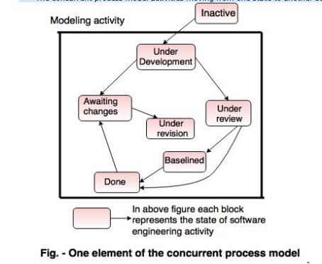
Advantages of the concurrent development model
- This model is applicable to all types of software development processes.
- It is easy for understanding and use.
- It gives immediate feedback from testing.
- It provides an accurate picture of the current state of a project.
Disadvantages of the concurrent development model
- It needs better communication between the team members. This may not be achieved all the time.
- It requires to remember the status of the different activities.

8.Describe the various phases of the Unified Process with the help of a diagram.
RUP and its Phases
Rational Unified Process (RUP) is a software development process for object-oriented models. It is also known as the Unified Process Model. It is created by Rational corporation and is designed and documented using UML (Unified Modeling Language). This process is included in IBM Rational Method Composer (RMC) product. IBM (International Business Machine Corporation) allows us to customize, design, and personalize the unified process.
RUP is proposed by Ivar Jacobson, Grady Bootch, and James Rambaugh. Some characteristics of RUP include use-case driven, Iterative (repetition of the process), and Incremental (increase in value) by nature, delivered online using web technology, can be customized or tailored in modular and electronic form, etc. RUP reduces unexpected development costs and prevents wastage of resources.
Phases of RUP :
There are total five phases of life cycle of RUP:
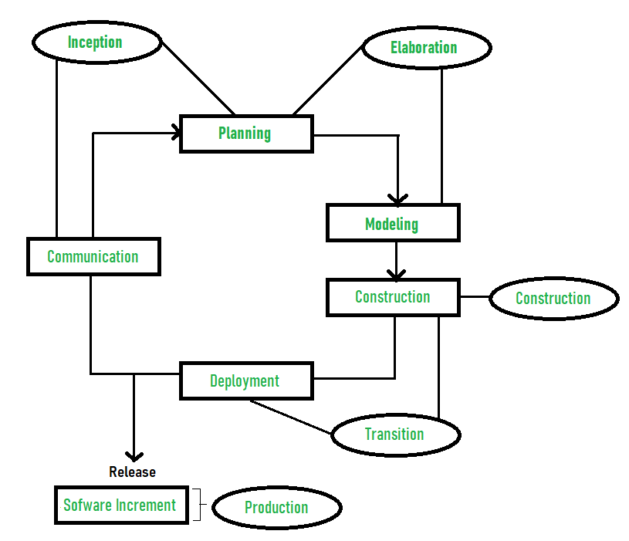
- Inception –
  - Communication and planning are main.
  - Identifies Scope of the project using use-case model allowing managers to estimate costs and time required.
  - Customers requirements are identified and then it becomes easy to make a plan of the project.
  - Project plan, Project goal, risks, use-case model, Project description, are made.
  - Project is checked against the milestone criteria and if it couldn’t pass these criteria then project can be either cancelled or redesigned.
- Elaboration –
  - Planning and modeling are main.
  - Detailed evaluation, development plan is carried out and diminish the risks.
  - Revise or redefine use-case model (approx. 80%), business case, risks.
  - Again, checked against milestone criteria and if it couldn’t pass these criteria then again project can be cancelled or redesigned.
  - Executable architecture baseline.
- Construction –
  - Project is developed and completed.
  - System or source code is created and then testing is done.
  - Coding takes place.
- Transition –
  - Final project is released to public.
  - Transit the project from development into production.
  - Update project documentation.
  - Beta testing is conducted.
  - Defects are removed from project based on feedback from public.
- Production –
  - Final phase of the model.
  - Project is maintained and updated accordingly.

9.What is a process pattern?
Process Patterns in Software Engineering
- Last Updated : 28 Dec, 2020
As the software team moves through the software process they encounter problems. It would be very useful if solutions to these problems were readily available so that problems can be resolved quickly. Process-related problems which are encountered during software engineering work, it identifies the encountered problem and in which environment it is found, then it will suggest proven solutions to problem, they all are described by process pattern. By solving problems a software team can construct a process that best meets needs of a project.
Uses of the process pattern :
At any level of abstraction, patterns can be defined. They can be used to describe a problem and solution associated with framework activity in some situations. While in other situations patterns can be used to describe a problem and solution associated with a complete process model.
Template :
- Pattern Name –
Meaningful name must be given to a pattern within context of software process (e.g. Technical Reviews).
- Forces –
The issues that make problem visible and may affect its solution also environment in which pattern is encountered.
Type :
It is of three types :
- Stage pattern –
Problems associated with a framework activity for process are described by stage pattern. Establishing Communication might be an example of a staged pattern. This pattern would incorporate task pattern Requirements Gathering and others.
- Task-pattern –
Problems associated with a software engineering action or work task and relevant to successful software engineering practice (e.g., Requirements Gathering is a task pattern) are defined by task-pattern.
- Phase pattern –
Even when the overall flow of activities is iterative in nature, it defines sequence of framework activities that occurs within process. Spiral Model or Prototyping might be an example of a phase pattern.

10.Write about the CMMI model.
Capability Maturity Model Integration (CMMI) is a successor of CMM and is a more evolved model that incorporates best components of individual disciplines of CMM like Software CMM, Systems Engineering CMM, People CMM, etc. Since CMM is a reference model of matured practices in a specific discipline, so it becomes difficult to integrate these disciplines as per the requirements. This is why CMMI is used as it allows the integration of multiple disciplines as and when needed.
Objectives of CMMI :
- Fulfilling customer needs and expectations.
- Value creation for investors/stockholders.
- Market growth is increased.
- Improved quality of products and services.
- Enhanced reputation in Industry.
CMMI Representation – Staged and Continuous :
A representation allows an organization to pursue a different set of improvement objectives. There are two representations for CMMI :

- Staged Representation :
  - uses a pre-defined set of process areas to define improvement path.
  - provides a sequence of improvements, where each part in the sequence serves as a foundation for the next.
  - an improved path is defined by maturity level.
  - maturity level describes the maturity of processes in organization.
  - Staged CMMI representation allows comparison between different organizations for multiple maturity levels.
- Continuous Representation :
  - allows selection of specific process areas.
  - uses capability levels that measures improvement of an individual process area.
  - Continuous CMMI representation allows comparison between different organizations on a process-area-by-process-area basis.
  - allows organizations to select processes which require more improvement.
  - In this representation, order of improvement of various processes can be selected which allows the organizations to meet their objectives and eliminate risks.
CMMI Model – Maturity Levels :
In CMMI with staged representation, there are five maturity levels described as follows :
- Maturity level 1 : Initial
  - processes are poorly managed or controlled.
  - unpredictable outcomes of processes involved.
  - ad hoc and chaotic approach used.
  - No KPAs (Key Process Areas) defined.
  - Lowest quality and highest risk.
- Maturity level 2 : Managed
  - requirements are managed.
  - processes are planned and controlled.
  - projects are managed and implemented according to their documented plans.
  - This risk involved is lower than Initial level, but still exists.
  - Quality is better than Initial level.
- Maturity level 3 : Defined
  - processes are well characterized and described using standards, proper procedures, and methods, tools, etc.
  - Medium quality and medium risk involved.
  - Focus is process standardization.
- Maturity level 4 : Quantitatively managed
  - quantitative objectives for process performance and quality are set.
  - quantitative objectives are based on customer requirements, organization needs, etc.
  - process performance measures are analyzed quantitatively.
  - higher quality of processes is achieved.
  - lower risk
- Maturity level 5 : Optimizing
  - continuous improvement in processes and their performance.
  - improvement has to be both incremental and innovative.
  - highest quality of processes.
  - lowest risk in processes and their performance.
CMMI Model – Capability Levels
A capability level includes relevant specific and generic practices for a specific process area that can improve the organization’s processes associated with that process area. For CMMI models with continuous representation, there are six capability levels as described below :
- Capability level 0 : Incomplete
  - incomplete process – partially or not performed.
  - one or more specific goals of process area are not met.
  - No generic goals are specified for this level.
  - this capability level is same as maturity level 1.
- Capability level 1 : Performed
  - process performance may not be stable.
  - objectives of quality, cost and schedule may not be met.
  - a capability level 1 process is expected to perform all specific and generic practices for this level.
  - only a start-step for process improvement.
- Capability level 2 : Managed
  - process is planned, monitored and controlled.
  - managing the process by ensuring that objectives are achieved.
  - objectives are both model and other including cost, quality, schedule.
  - actively managing processing with the help of metrics.
- Capability level 3 : Defined
  - a defined process is managed and meets the organization’s set of guidelines and standards.
  - focus is process standardization.
- Capability level 4 : Quantitatively Managed
  - process is controlled using statistical and quantitative techniques.
  - process performance and quality is understood in statistical terms and metrics.
  - quantitative objectives for process quality and performance are established.
- Capability level 5 : Optimizing
  - focuses on continually improving process performance.
  - performance is improved in both ways – incremental and innovation.
  - emphasizes on studying the performance results across the organization to ensure that common causes or issues are identified and fixed.
11.What is Agile SE? Describe the Agile Model .

Agile Model
The meaning of Agile is swift or versatile. "Agile process model" refers to a software development approach based on iterative development. Agile methods break tasks into smaller iterations, or parts do not directly involve long term planning. The project scope and requirements are laid down at the beginning of the development process. Plans regarding the number of iterations, the duration and the scope of each iteration are clearly defined in advance.

Phases of Agile Model:
Following are the phases in the Agile model are as follows:
- Requirements gathering
- Design the requirements
- Construction/ iteration
- Testing/ Quality assurance
- Deployment
- Feedback
1. Requirements gathering: In this phase, you must define the requirements. You should explain business opportunities and plan the time and effort needed to build the project. Based on this information, you can evaluate technical and economic feasibility.
2. Design the requirements: When you have identified the project, work with stakeholders to define requirements. You can use the user flow diagram or the high-level UML diagram to show the work of new features and show how it will apply to your existing system.
3. Construction/ iteration: When the team defines the requirements, the work begins. Designers and developers start working on their project, which aims to deploy a working product. The product will undergo various stages of improvement, so it includes simple, minimal functionality.
4. Testing: In this phase, the Quality Assurance team examines the product's performance and looks for the bug.
5. Deployment: In this phase, the team issues a product for the user's work environment.
6. Feedback: After releasing the product, the last step is feedback. In this, the team receives feedback about the product and works through the feedback.
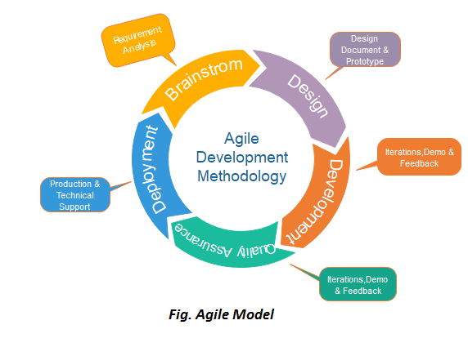

Agile Testing Methods:
- Scrum
- Crystal
- Dynamic Software Development Method(DSDM)
- Feature Driven Development(FDD)
- Lean Software Development
- eXtreme Programming(XP)

Advantage(Pros) of Agile Method:
- Frequent Delivery
- Face-to-Face Communication with clients.
- Efficient design and fulfils the business requirement.
- Anytime changes are acceptable.
- It reduces total development time.

Disadvantages(Cons) of Agile Model:
- Due to the shortage of formal documents, it creates confusion and crucial decisions taken throughout various phases can be misinterpreted at any time by different team members.
- Due to the lack of proper documentation, once the project completes and the developers allotted to another project, maintenance of the finished project can become a difficulty.

Agile SDLC model is a combination of iterative and incremental process models with focus on process adaptability and customer satisfaction by rapid delivery of working software product. Agile Methods break the product into small incremental builds. These builds are provided in iterations. Each iteration typically lasts from about one to three weeks. Every iteration involves cross functional teams working simultaneously on various areas like −
- Planning
- Requirements Analysis
- Design
- Coding
- Unit Testing and
- Acceptance Testing.
At the end of the iteration, a working product is displayed to the customer and important stakeholders.

What is Agile?
Agile model believes that every project needs to be handled differently and the existing methods need to be tailored to best suit the project requirements. In Agile, the tasks are divided to time boxes (small time frames) to deliver specific features for a release.
Iterative approach is taken and working software build is delivered after each iteration. Each build is incremental in terms of features; the final build holds all the features required by the customer.
Here is a graphical illustration of the Agile Model −
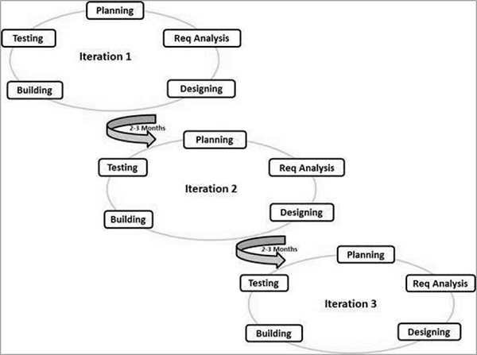
The Agile thought process had started early in the software development and started becoming popular with time due to its flexibility and adaptability.
The most popular Agile methods include Rational Unified Process (1994), Scrum (1995), Crystal Clear, Extreme Programming (1996), Adaptive Software Development, Feature Driven Development, and Dynamic Systems Development Method (DSDM) (1995). These are now collectively referred to as Agile Methodologies, after the Agile Manifesto was published in 2001.
Following are the Agile Manifesto principles −
- Individuals and interactions − In Agile development, self-organization and motivation are important, as are interactions like co-location and pair programming.
- Working software − Demo working software is considered the best means of communication with the customers to understand their requirements, instead of just depending on documentation.
- Customer collaboration − As the requirements cannot be gathered completely in the beginning of the project due to various factors, continuous customer interaction is very important to get proper product requirements.
- Responding to change − Agile Development is focused on quick responses to change and continuous development.

Agile Model - Pros and Cons
Agile methods are being widely accepted in the software world recently. However, this method may not always be suitable for all products. Here are some pros and cons of the Agile model.
The advantages of the Agile Model are as follows −
- Is a very realistic approach to software development.
- Promotes teamwork and cross training.
- Functionality can be developed rapidly and demonstrated.
- Resource requirements are minimum.
- Suitable for fixed or changing requirements
- Delivers early partial working solutions.
- Good model for environments that change steadily.
- Minimal rules, documentation easily employed.
- Enables concurrent development and delivery within an overall planned context.
- Little or no planning required.
- Easy to manage.
- Gives flexibility to developers.
The disadvantages of the Agile Model are as follows −
- Not suitable for handling complex dependencies.
- More risk of sustainability, maintainability and extensibility.
- An overall plan, an agile leader and agile PM practice is a must without which it will not work.
- Strict delivery management dictates the scope, functionality to be delivered, and adjustments to meet the deadlines.
- Depends heavily on customer interaction, so if customer is not clear, team can be driven in the wrong direction.
- There is a very high individual dependency, since there is minimum documentation generated.
- Transfer of technology to new team members may be quite challenging due to lack of documentation.

